Source ID - 76817999

Source Title - Chinese Pharmaceutical Journal

Agreement URL - <http://journal11.magtechjournal.com/Jwk_zgyxzz/CN/home>

NOTE – Chinese TOC should be captured.

Capture Year

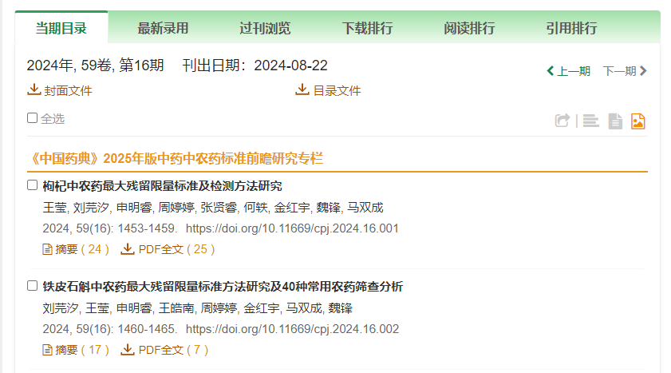

Capture Month in words (Ex in here 8 = August)

Volume

Issue

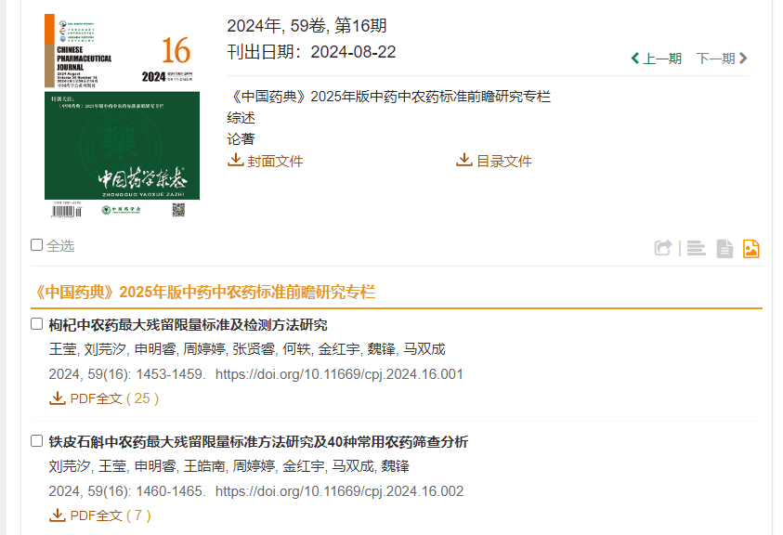

Click to capture meta data

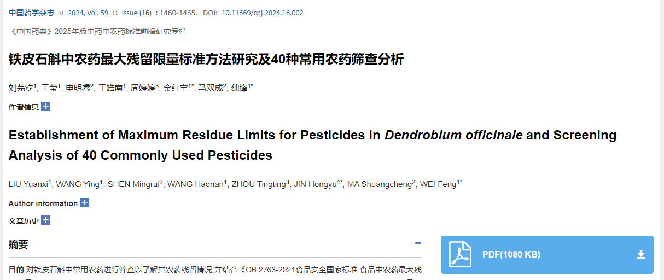

Click to download PDF

Article title

Page range

DOI number